Flexible Antenna Design
Authored by Jacob Vaught

Abstract:
This study details the creation of a compact, flexible split-ring co-planar waveguide antenna for UAV deployable SHM sensors. Emphasizing lightweight design, it explores flexible substrates and conductive materials for optimal performance. The antenna was modeled using Finite Difference methods and prototyped with a conductive ink printer on polyimide. Future goals include miniaturization, harmonic reduction, and enhanced manufacturing precision. This work aims to advance low-cost UAV SHM sensor technology, offering a robust, efficient antenna design with potential market impact.

Introduction:
The UAV deployable Sensor packages developed by Dr. Downey’s research lab is used for structural health monitoring of structures after natural events, such as floods, earthquakes, and fires. Currently to determine health of structures, a crew has to go to the site and determine their integrity. Thus it would be advantageous to automate the process, particularly for hard to access points. Dr Downey’s groups has shown that it is possible to build and develop theses sensor packages at a low cost, however the data traditionally had to be retrieved from the devices after collecting it. Dr. Downey’s group developed a prototype that used RF to transmit the data, however it was no longer UAV deployable due to the bulky antenna. This paper’s work is aimed at combining the RF and the sensor package in such a way that it still maintains its UAV deployable status while not adding on a deal of complexity and weight.

Figure 1: UAV Deployable SHM Sensor Packages

Background Research:
The design and implementation of compact and flexible antennas have become increasingly important for a variety of applications, including structural health monitoring (SHM) in the aftermath of natural disasters. The need for lightweight, efficient, and UAV-deployable sensor packages is critical for timely and safe assessment of structural integrity without the necessity for direct human intervention.
In the development of flexible, compact antennas, several methodologies were explored, all of which necessitated the use of a substrate. The choice of substrate is crucial as it influences the antenna's flexibility, the application of conductive traces, and the propagation of electromagnetic waves. Initially, this project considered two primary substrates: fabric and Polyimide. Fabric, while offering exceptional flexibility, presents several challenges. It is prone to stretching, which can distort the antenna's shape and alter its performance. Additionally, applying a conductive trace to fabric substrates can be problematic due to their porous and uneven surfaces.
On the other hand, Polyimide is a more favored option in the realm of flexible antennas, recognized for its superior thermal stability, mechanical properties, and electrical insulation. These attributes render it highly suitable for flexible electronics and antenna applications. With a relative permittivity range of 3.2 to 3.5, Polyimide supports effective electromagnetic wave propagation, a critical aspect for RF communication. Furthermore, research has shown that the flexibility offered by Polyimide does not significantly detract from the antenna's performance, making it an excellent choice for applications where flexibility and compact design are paramount.
In addition to the importance of the substrate, the choice of conductive materials for the flexible electronic traces significantly impacts the performance and feasibility of producing flexible antennas. The utilization of conductive inks offers a balance between conductivity and flexibility, enabling the printing of antennas directly onto flexible substrates like Polyimide. This approach not only facilitates the production of lightweight antennas but also allows for rapid prototyping.
RF communication is vital for transmitting data from remote sensors back to monitoring stations, especially in SHM applications where direct access to structures may be hazardous or impossible. The design of the antenna significantly affects the quality and reliability of this data transmission. Therefore, optimizing antenna performance for specific frequency bands, while minimizing size and weight, is essential for integrating these components into UAV-deployable sensor packages.

Antenna Design Selection:
Upon thorough examination of resources including the notable "Practical Microstrip and Printed Antenna Design" and other relevant studies such as the detailed research found at https://cdn.intechopen.com/pdfs/37715/InTech-Design_fabrication_and_testing_of_flexible_antennas.pdf, it has been determined that the utilization of a co-planar waveguide split ring antenna, specifically printed on a single side of a Kapton substrate, presents numerous benefits. This selection is driven by the simplicity and efficiency of its implementation which aligns well with the project's objectives.
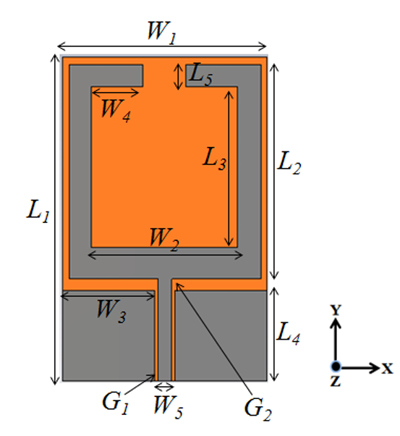
Figure 2: Co-Planer Waveguide Split-ring Antenna Design
The design's notable advantages stem from its compactness and inherent flexibility, making it particularly suitable for applications where space and adaptability are critical factors. Additionally, this antenna design has been meticulously engineered to function optimally within the 2.45 GHz frequency band. This is a strategic choice, as it aligns perfectly with the operational frequency of the NRF24 module transmitter, ensuring compatibility and enhancing the system's overall performance. The decision to proceed with this specific antenna design is further justified by its potential for low-cost production and ease of integration into existing systems, without compromising on the quality or efficiency of signal transmission and reception. This aligns with the broader goal of achieving a balance between functionality, cost-efficiency, and performance in real-world applications. An image of the design is seen in Figure 1.

Simulation Techniques:
In our methodology to ensure the functionality and efficacy of the antenna design, we initially embarked on creating a digital model within the Advanced Design System (ADS) environment, leveraging its comprehensive antenna simulation suite. The modeling process was meticulous, adopting a substrate thickness specification of 0.0054 inches coupled with a substrate relative permittivity set at 3.5, to mirror real-world material properties accurately. Following the establishment of these foundational parameters, the antenna structure was then constructed in a two-dimensional framework to facilitate precise simulation and analysis. This stage involved the strategic placement and integration of ground planes in relation to the antenna's geometry to emulate its intended operational context accurately.
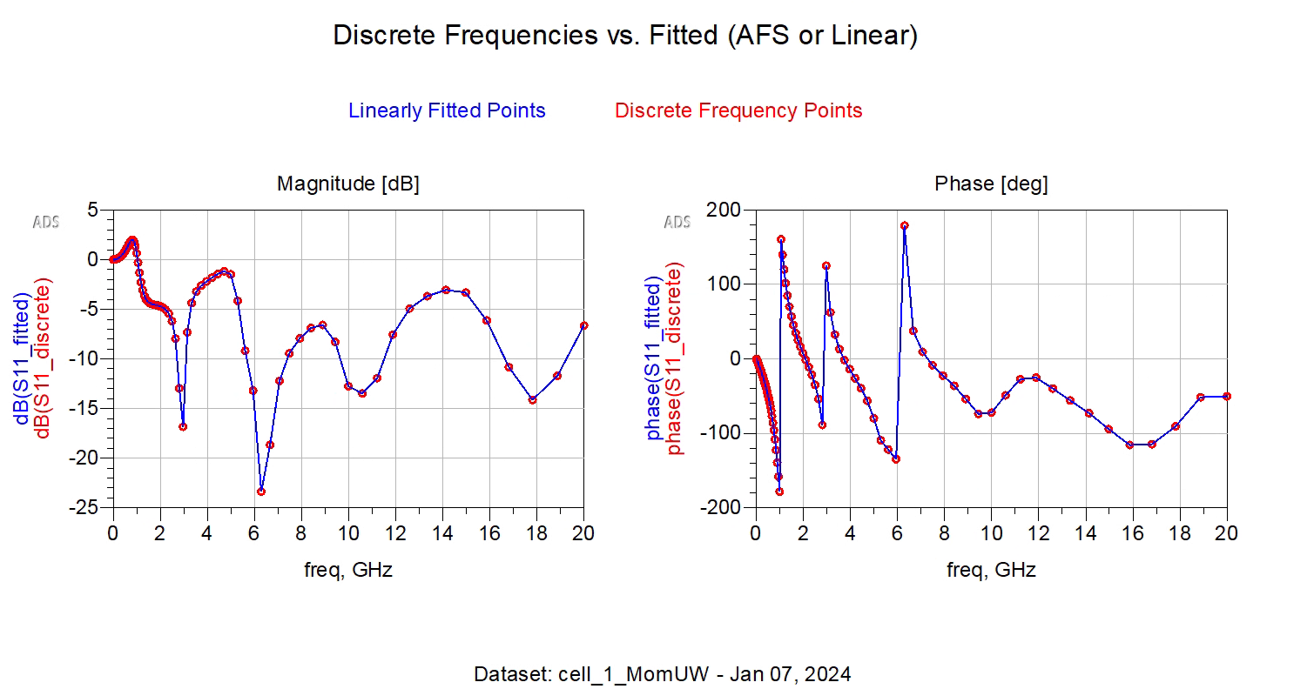
Figure 3: Frequency Response of antenna
The culmination of this detailed simulation process is depicted in Figure 2, showcasing the rendered antenna model within the ADS interface. This visualization not only represents the geometric and material specifications of the antenna but also serves as a baseline for subsequent simulation exercises aimed at evaluating the antenna's performance characteristics and operational suitability within its designed frequency bands and application environments.
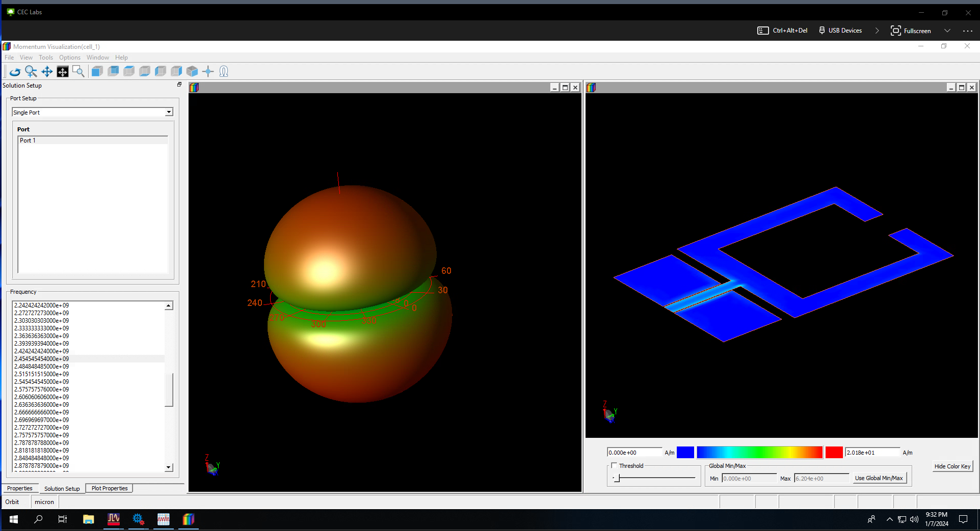
Figure 4: Electromagnetic propagation field of antenna

Prototype Development:
The prototype showcased has been developed using a conductive silver particle-based ink with a resistivity of 1.27×10^−4 Ω.m. The use of silver ink is notable for its high conductivity, which is critical for efficient antenna operation. The low resistivity helps in reducing power losses, a key factor for antennas used in battery-operated systems.
The antenna was printed using a Voltera One printer, a tool commonly used for prototyping electronic circuits by dispensing conductive inks and insulating pastes on various substrates. This method allows for rapid prototyping and testing of antenna designs. After printing, the antenna underwent a heat treatment process. This step is critical as it ensures the conductive ink is properly sintered, forming a continuous conductive layer necessary for the antenna's operation. Heat treatment improves the mechanical strength of the printed tracks and reduces the resistivity of the conductive ink, thus enhancing the antenna's performance.
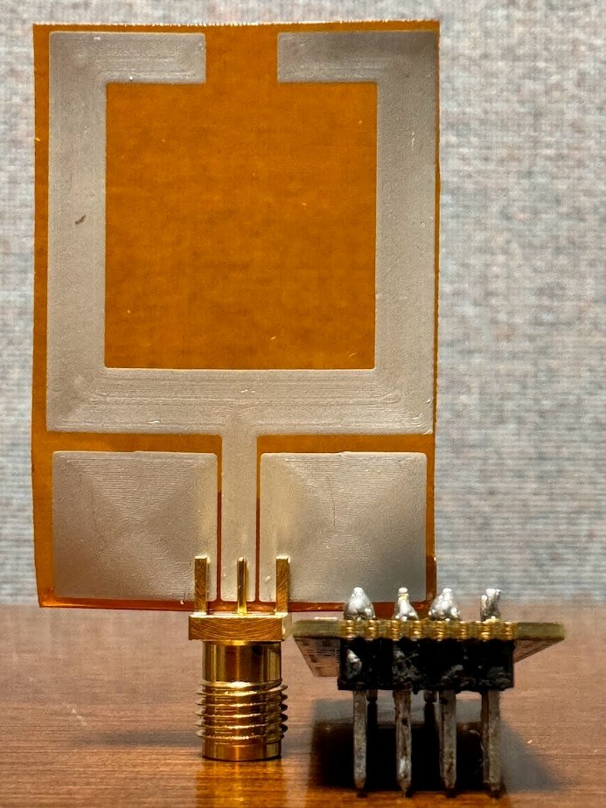
Figure 5: Antenna test setup
During the prototype manufacturing phase, we encountered limitations due to the Voltera printer being equipped only with low-resolution nozzles. This lack of finer precision in the printing apparatus necessitates the acquisition of a more accurate tip to ensure the designs achieve the desired fidelity. The resultant inaccuracies from this equipment shortfall are exemplified in Figure 4. Consequently, this resolution constraint has led to the antenna's frequency not being precisely adjusted within the optimal range initially targeted.
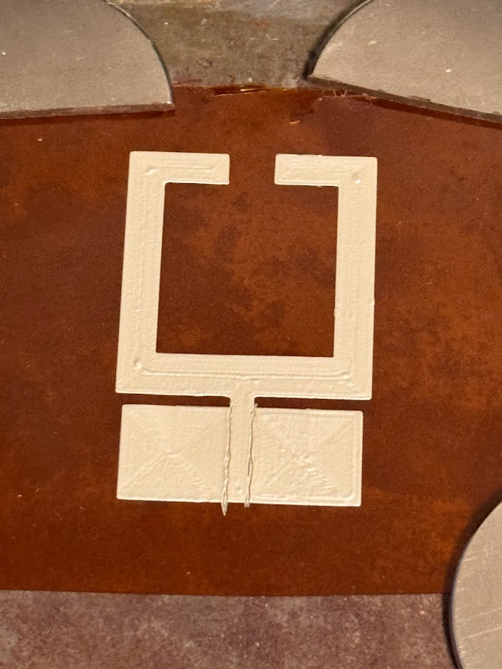
Figure 6: failed Antenna print

Testing Methodology
The proposed approach for evaluating the antenna's performance involves a structured testing protocol with the NRF24 Module. The methodology encompasses setting up fixed measurement points to ensure a clear Line of Sight (LoS) between the transmitting and receiving stations. This configuration is essential to reduce interference and enhance the precision of signal strength measurements.
At each fixed distance endpoint, another NRF24 Module, outfitted with its standard integrated antenna, will be placed to act as the receiver. This arrangement allows for a direct evaluation of signal transmission and strength between the modified and unmodified antenna setups.
The antenna’s efficiency will be quantified by utilizing the NRF24 Module's in-built signal strength measurement function, which accurately gauges the power of received signals in decibels (dB). This feature enables detailed analysis of signal degradation over various distances, offering a clear standard for comparison.
Testing will be performed repeatedly across different distances, with several iterations at each point to ensure data consistency and reliability. Conducting these tests under uniform conditions is critical for generating a comprehensive dataset that accurately reflects the antenna’s operational performance.
Upon completing the empirical tests, the gathered data will be thoroughly analyzed and benchmarked against the performance metrics of a standard, unmodified NRF24 module under the same environmental conditions. This side-by-side comparison is crucial to assess the modified antenna's effectiveness in practical settings.it would be compared to a traditional unmodified NRF24 module strength at the same distances. View a diagram of the test in Fig 6.
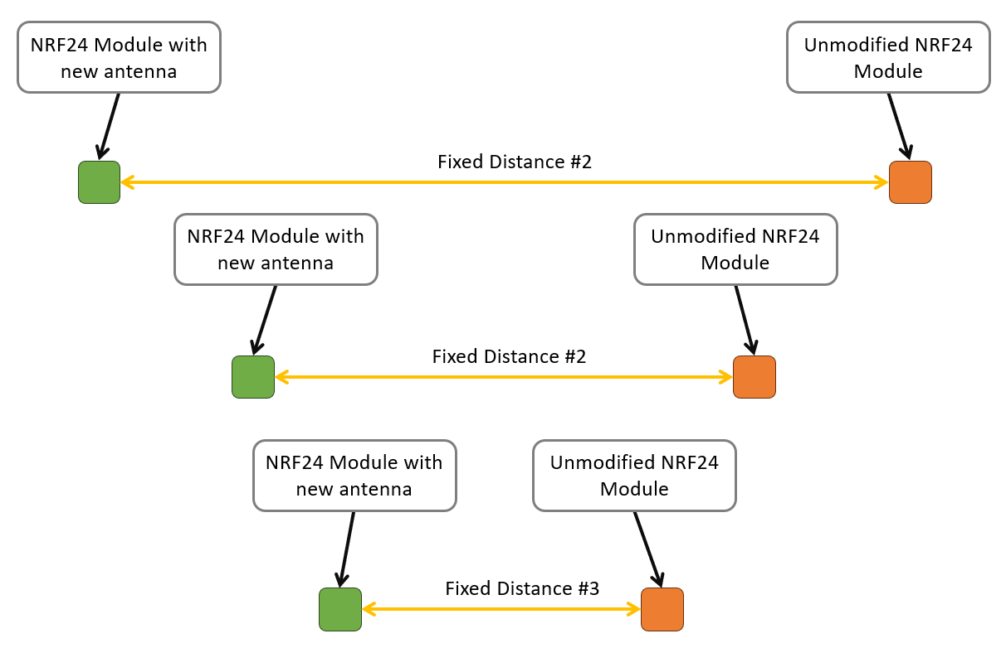
Figure 7: Proposed Testing methodology for antenna effectiveness

Conclusion:
This study, spearheaded by Jacob Vaught, has successfully developed a compact, flexible split-ring co-planar waveguide antenna, specifically tailored for UAV deployable Structural Health Monitoring (SHM) sensors. The research has demonstrated the viability of using lightweight, flexible substrates combined with conductive materials to create an efficient antenna design that does not compromise the UAV's deployability due to weight or size constraints.
The Finite Difference method-based modeling, coupled with prototype development using conductive ink on polyimide substrates, has laid the groundwork for future advancements in antenna design. The iterative design and testing process, although challenged by the limitations of current printing technology, underscore the importance of precision in manufacturing to achieve the desired frequency and performance characteristics.
Significant findings from this research include the successful integration of the antenna within the UAV sensor package, maintaining the package’s lightweight and deployability features while ensuring robust RF communication capabilities. The designed antenna operates effectively within the 2.45 GHz frequency band, aligning with the operational frequency of the NRF24 module transmitter, which is critical for real-time data transmission in SHM applications.
The comparative testing methodology, involving the NRF24 Module at fixed distances and clear line-of-sight conditions, has provided valuable insights into the antenna’s performance relative to standard unmodified modules. This rigorous evaluation has highlighted the antenna’s potential to maintain reliable communication over distances, crucial for UAV SHM applications in assessing the health of structures post-natural disasters.

